Verbs for Communicating and Presenting:
- Briefing, Designing and Collaborating
Prezi is a cloud-based presentation software that opens up a new world between whiteboards and slides. The zoomable canvas makes it fun to explore ideas and the connections between them. The result: visually captivating presentations that lead your audience down a path of discovery.
Prezi is also great for collaboration through the share function and can be used for making flowcharts and graphic organizers as well as presentations. It is very easy to make a Prezi but making excellent Prezis takes some planning and creativity.
- Go to http://prezi.com and click on Sign Up Now. Scroll down to the bottom and click on Student/Teacher Licenses. Click on Get. This will give you a better account than the regular free account. You must use your board email. Follow the instructions to register and don’t forget to check your email to confirm your account before proceeding to your first Prezi.

- To make your first Prezi, you can watch the tutorials on the Learn tab (although they will probably make more sense once you have tried to make your first Prezi) or just dive in and click New Prezi. Give the Prezi a title (it can be changed later).

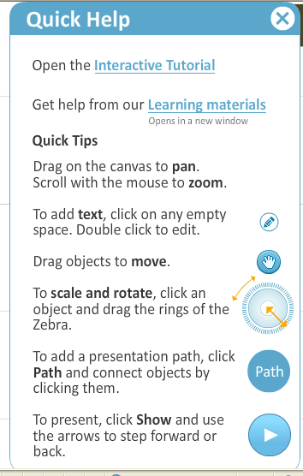
- Preview some of the templates (it’s probably best to choose a blank canvas), pick one and start editing.

- Don’t skip the tutorial that opens the first time you make a Prezi. It takes you through all the steps to get started with a basic Prezi. If you ever forget what was in the tutorial, click on Help in the top right and then Interactive Tutorial. The Help menu also give basic features.

- Have fun!

The Ultimate Guide to Prezi: http://thewikiman.org/blog/?p=1690

Another guide (Prezi tools have slightly changed since this was made): www.activehistory.co.uk/Miscellaneous/free_stuff/worksheets/Prezi.pdf

