Voicethreads allow every student a voice. They are more personal than wikis or discussion boards. It feels like you are right beside the person while they comment. The controls are intuitive and there are step-by-step tutorials.

A Voicethread:
- allows you to take collections of media and have conversations about them
- lets you comment from anywhere, at anytime
- uses pictures, presentations, documents, videos or combinations of all of them
- has many options for privacy and moderation of comments
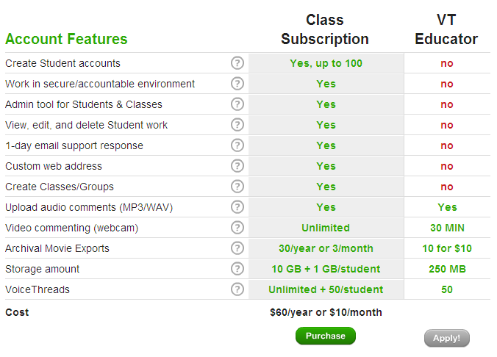
- requires no software to download because it loads in your browser

- Go to www.voicethread.com

- Scroll down to the bottom of the page and click on K-12 under Products.

- On the next page that opens, choose Single Educator.

- Under VT educator, click on Apply.

- Complete the registration.

- Click on the My Voice tab and then on Tutorials on the left side.

- Watch the What’s a Voicethread... tutorial. To find it, you may need to scroll down the list by clicking the arrows below the tutorials. (Click on the arrow button on the bottom right corner to advance slides—you do not need to listen to every comment.)

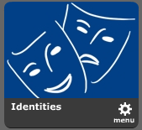
- When it is done, close the tutorial by clicking on the X in the top right hand corner.

- Watch the Identities tutorial. You will be using identities to make comments later in this activity.

- Click on Browse. Explore these Voicethreads and, when you are ready to make a comment, click on the icon in the bottom left of the Voicethread. Choose a pre-made identity or create your own.
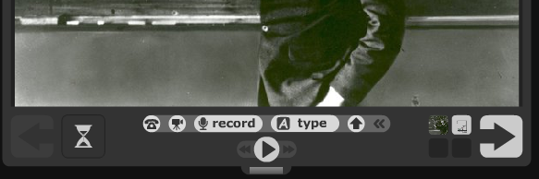
- Try out all three types of comments—make a text, voice, and webcam comment. You can delete a comment and re-record it if you are not happy with it—so don’t worry about mistakes or awkward moments.
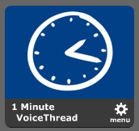
- Make your own Voicethread! First watch the tutorial called 1 Minute
Voicethread.

